BUSINESS INSIGHT REPORT
Northwind Traders Sales Dashboard Analysis
Prepared using Microsoft Power BI

Submitted by
Pavithran D
Register Number: 5272510215
B. Com (FinTech with AI)
2nd Year

1. Introduction
The Northwind Traders dataset is a widely used sample business dataset representing the sales operations of a specialty food distribution company. It contains detailed records of customers, employees, products, product categories, orders, order line items, and shipping information, making it well suited for demonstrating end-to-end sales and performance analysis.
The Power BI dashboard built on this dataset consolidates key sales, order, and customer metrics into a single interactive view. It allows a user to track overall business performance through summary KPI cards, examine how sales are distributed across product categories, observe order trends over time, and compare performance across employees and countries/regions.
This Business Insight Report accompanies the dashboard. Its purpose is to interpret the figures shown on the dashboard, highlight the most important patterns in the data, and translate those observations into practical business insights and recommendations for Northwind Traders.
2. Dashboard Overview
Dashboard Screenshot
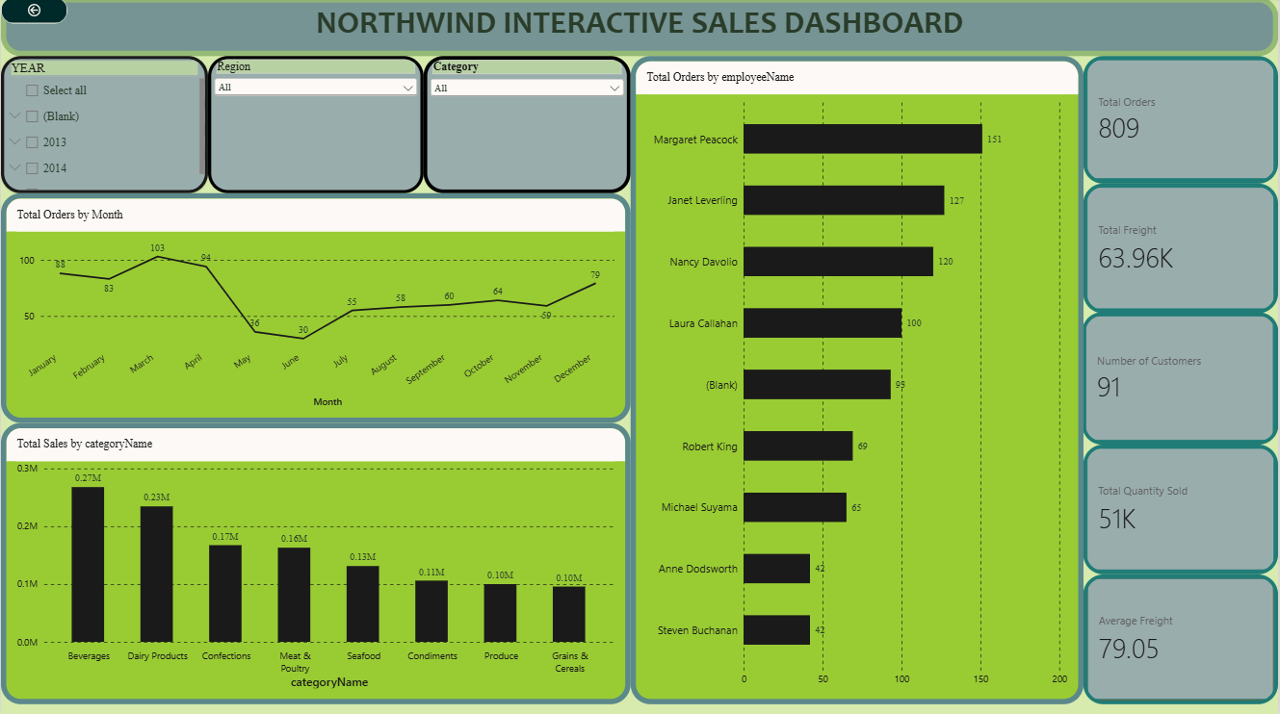
Fig: Northwind Interactive Sales Dashboard – full view
The dashboard is designed to give a single-page overview of Northwind Traders' sales performance. It combines summary KPI cards with visual breakdowns of sales, orders, and employee performance, and lets the user filter every visual dynamically using slicers.
Key Components
- KPI cards – Total Orders, Total Sales, Total Quantity Sold, Total Freight, Average Freight, and Number of Customers
- Orders by Month – a line chart showing how order volume changes over time
- Sales by Product Category – a column chart comparing revenue across the eight product categories
- Orders by Employee – a bar chart comparing order counts handled by each sales employee
- Category Tooltip page – a supporting tooltip view showing Total Sales, Total Orders, and Total Quantity Sold on hover
Interactive Filters Available
- Category – filters all visuals to a single product category (e.g., categoryName slicer)
- Country/Region – filters all visuals to a selected customer country
- Year – filters the dashboard to a specific order year, where a date-based slicer is used
Selecting any of these filters instantly updates the KPI cards and every chart on the page, allowing quick drill-down from company-wide totals to a specific category, country, or time period.
3. KPI Analysis
Total Orders
The dashboard records a total of 809 distinct orders across the full dataset (July 2013 – May 2015). This reflects a steady, ongoing stream of order activity rather than a one-off spike, indicating a business with a consistent, repeat customer base.
Total Quantity Sold
A total of 51,317 units were sold across all product categories. Combined with the order count, this gives an average of roughly 63 units per order, suggesting that most orders are bulk/wholesale in nature rather than small single-item purchases.
Total Freight
Total freight (shipping cost) across all orders amounts to $63,955.02. Freight represents a meaningful cost component of order fulfilment and should be tracked alongside sales, since it directly affects net margins on each order.
Average Freight
The average freight cost per order is $79.05. This benchmark can be used to flag unusually expensive shipments (for example, distant destinations or heavy orders) that may need renegotiated shipping rates.
No. of Customers
The dataset covers 91 unique customers spread across 21 countries. This is a moderately sized, geographically diverse customer base, which supports the case for a country/region-level view of performance rather than a single global average.

KPI | Value | Interpretation
Total Orders | 809 | Steady order flow over the ~22-month period covered by the data
Total Quantity Sold | 51,317 units | High per-order volume; consistent with bulk/wholesale ordering
Total Freight | $63,955.02 | Notable cumulative shipping cost across all orders
Average Freight | $79.05 | Useful baseline for identifying unusually costly shipments
No. of Customers | 91 | Moderately sized, internationally spread customer base
4. Product Category Performance Analysis
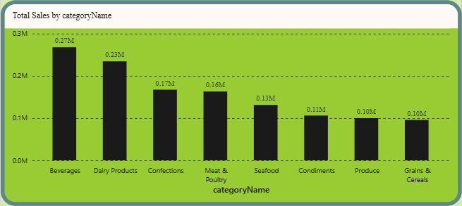
Fig: Total Sales by categoryName (from the dashboard)
- Highest-selling category: Beverages, with total sales of $267,868.18
- Lowest-selling category: Grains & Cereals, with total sales of $95,744.59
- Relative differences: Beverages outsells Grains & Cereals by nearly 2.8 times. Dairy Products ($234,507.29) and Confections ($167,357.23) are the next strongest categories, while Condiments and Produce sit in the lower-middle band.
- Important observations: The top four categories (Beverages, Dairy Products, Confections, Meat & Poultry) together account for well over half of total company sales, showing that revenue is concentrated in a relatively small set of categories rather than spread evenly across all eight.

Key Insight: Beverages is Northwind's strongest revenue driver and Grains & Cereals its weakest, so category-level attention (promotions, pricing, or shelf space) is best focused on protecting the Beverages lead while investigating why Grains & Cereals underperforms.

5. Monthly Order Trend Analysis
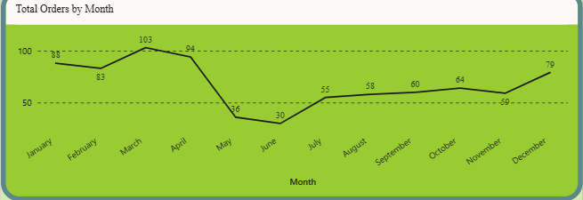
Fig: Total Orders by Month (from the dashboard)
- Highest-order month: March, with 103 orders
- Lowest-order month: May, with only 16 orders
- Overall pattern: Orders climb steadily from January (88) to a peak in March (103), stay strong through April (94), then fall sharply into May (16) and June (30) — the two weakest months of the year — before recovering gradually from July onward, closing the year at 79 in December.
- Major fluctuations: The sharpest swing is the April-to-May drop, where order volume falls by more than 80% in a single month, before a slower, steady climb through the second half of the year.

Key Insight: Orders follow a clear seasonal cycle: a strong first-quarter peak (Jan–Apr), a sharp mid-year trough (May–June), and a gradual recovery into year-end. Inventory, staffing, and marketing plans should treat May–June as the low season and Q1 as the period requiring the most capacity.
6. Regional / Filter-Based Analysis
Since the dashboard uses a country/region slicer rather than a separate regional chart, the table below demonstrates how the dashboard changes when three different countries are selected as the filter.

KPI, Category, Monthly Order, and Employee Performance Changes
Region | Major Observation | Business Insight
Germany | 120 orders, $227,796.66 in sales, 9,075 units, average freight $92.63. Beverages is the top category and Margaret Peacock is the top-performing employee (25 orders). | Germany is the single largest country by order count, making it a priority market for account management and stock availability.
USA | 119 orders, $243,618.89 in sales (highest of the three), 9,223 units, average freight $115.38 (the highest of the three). Beverages leads again; Janet Leverling is the top employee (21 orders). | The USA generates the most revenue despite having slightly fewer orders than Germany, and its notably higher freight cost signals an opportunity to review shipping arrangements for that market.
Brazil | 81 orders, $103,060.70 in sales, 4,098 units, average freight $58.18 (the lowest of the three). Beverages is again the top category; Margaret Peacock leads with 20 orders. | Brazil trails Germany and the USA on both orders and sales, but its low freight cost suggests efficient regional logistics that could be modelled in other markets.
Across all three countries, Beverages remains the top-selling category, which reinforces the earlier finding that Beverages is Northwind's most universally strong category rather than a region-specific effect.
7. Employee Performance Analysis
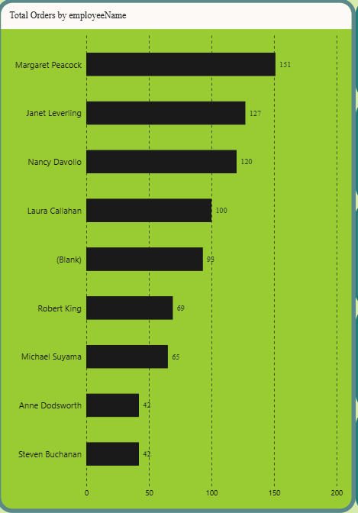
Figure 3: Total Orders by employeeName (from the dashboard)

Discuss:
- Highest-performing employee: Margaret Peacock, with 151 orders handled
- Lowest-performing employees: Steven Buchanan and Anne Dodsworth, tied at 42 orders each
- Difference between employees: Margaret Peacock handles roughly 3.6 times as many orders as the lowest-performing employees, and about 24 more orders than the next-highest employee, Janet Leverling (127). The chart also shows 99 orders under (Blank) — orders whose employee record is missing from the employee table — which should be investigated and reassigned so the performance comparison is complete.
- Changes after applying filters: When the dashboard is filtered to individual countries (as in Section 7), Margaret Peacock remains the top performer in both Germany and Brazil, while Janet Leverling leads in the USA — showing that overall company-wide rankings are not identical to country-level rankings.

Key Insight: Order handling is uneven across the sales team, with a clear top tier (Margaret Peacock, Janet Leverling, Nancy Davolio, Laura Callahan) and a lower tier of employees handling under half as many orders — a useful basis for workload review or targeted coaching. The sizeable (Blank) bucket also points to a data-quality gap worth fixing before performance is reviewed.
8. Business Insights
Insight 1
Revenue is concentrated in a few categories — Beverages, Dairy Products, Confections, and Meat & Poultry together generate the majority of total sales, while Grains & Cereals and Produce lag well behind, showing an opportunity to grow the weaker categories or to double down on the strong ones.
Insight 2
Order volume grew steadily over the period covered and peaks every winter (December–March), meaning Northwind's demand is not flat but has a predictable seasonal rhythm that inventory and staffing plans should account for.
Insight 3
Sales performance and freight cost both vary significantly by country — the USA generates the highest sales but also the highest average freight, while Brazil has much lower freight despite solid order volume — indicating that shipping efficiency, not just sales volume, differs meaningfully by region.
9. Business Recommendations
- Product category planning: Invest marketing and promotional effort in Grains & Cereals and Produce to close the gap with the stronger categories, while continuing to protect Beverages' market-leading position.
- Inventory planning: Increase stock levels of Beverages and Dairy Products ahead of the December–March peak season identified in the monthly trend analysis, to avoid stock-outs during the busiest period.
- Regional strategy: Review shipping/logistics arrangements in the USA, where average freight cost ($115.38) is significantly higher than in Brazil ($58.18) despite comparable or lower order volume, to identify potential savings.
- Employee performance: Investigate the workload and support structure for lower-performing employees such as Steven Buchanan and Anne Dodsworth, and consider having top performers like Margaret Peacock mentor the team on order-handling practices.
- Monthly order planning: Align staffing and supply schedules with the recurring winter demand peak (Dec–Mar) rather than a flat year-round plan, since order volume during this window is roughly double the mid-year low.
- Freight management: Set an internal benchmark around the current average freight of $79.05 per order and flag orders that exceed it significantly for cost review.
- Customer targeting: Given that Germany, the USA, and Brazil together account for the largest share of orders, prioritise account management and retention efforts in these three countries while exploring growth potential in smaller markets.
10. Conclusion
The Power BI dashboard built on the Northwind Traders dataset shows a business with steady, growing order activity (809 orders generating $1,265,793.04 in total sales), a customer base of 91 companies across 21 countries, and clearly uneven performance across product categories, countries, and employees.
The most important business insight is that Beverages consistently drives the largest share of revenue across every country examined, while order volume follows a predictable winter seasonal peak — two patterns that should directly shape inventory and staffing decisions.
The key recommendation is to align inventory and staffing capacity with the December–March demand peak while addressing the higher freight cost seen in the USA market, since these two levers offer the clearest near-term improvement to profitability.
Overall, Power BI made it possible to move from raw transactional tables (orders, order details, products, customers, employees) to a single interactive view where KPI cards, trend charts, and category/employee breakdowns could all be filtered together — turning scattered data into a small set of clear, actionable business insights.

